Micro Programming

[Design Project/Experiment Report]



Biometric Lock System

Submitted by:

Muhammad Huzaifa | 23L-6067

Submitted to:
Aliha Tanveer

27/11/2025

Department of Electrical Engineering
National University of Computer and Emerging Sciences, Lahore

Introduction
- Problem Analysis

Design Requirements
- Feasibility Analysis

Possible Solutions
- Preliminary Design

Design Description

Software Simulation

Experimental Results
- Performance Analysis
- Future Scope

Social and Cultural Implications
- Conclusion References

The modern era of embedded systems has enabled the development of efficient, secure, and automated access-control solutions. Biometric identification, particularly fingerprint recognition, is widely used due to its high reliability and ease of use. This project focuses on designing and implementing a Fingerprint-Based Security System using the PIC16F877A microcontroller and the AS608 optical fingerprint sensor.
The system identifies authorized users through fingerprint matching and controls physical access using an SG90 servo motor, which acts as a door lock mechanism. A 16×2 LCD is used to display system status and instructions, while LEDs provide additional visual feedback. The complete program is written in C (XC8 compiler), ensuring fast execution and reliable communication through UART with the AS608 module.
This project demonstrates how microcontroller-based biometric systems can be implemented using digital electronics and embedded programming. It integrates key concepts such as UART communication, servo PWM control, LCD interfacing, internal pull-up buttons, and EEPROM-based fingerprint storage. The result is a compact, functional, and practical security system suitable for academic learning and real-world application. Furthermore, the system is designed with modularity and scalability in mind, allowing future enhancements such as multi-user enrollment, variable access levels, wireless monitoring, and integration with IoT platforms. The structured code architecture separates hardware drivers from application logic, making the system easier to debug, upgrade, and adapt to different sensors or microcontrollers. By combining hardware interfacing with real-time embedded programming, this project not only strengthens practical engineering skills but also highlights the importance of biometrics in modern security infrastructures.

The need for secure and reliable access-control systems has grown significantly as traditional methods such as mechanical keys and PIN codes have become increasingly vulnerable to loss, theft, duplication, or guessing. Conventional locking mechanisms offer limited protection because they depend on something the user possesses or remembers, both of which can be compromised. In environments where security and controlled entry are critical, there is a strong demand for an authentication method that is both highly accurate and resistant to unauthorized access. This project addresses that need by implementing a biometric-based door-lock system using fingerprint verification.
The core problem was to design a system capable of identifying a user based solely on their biometric fingerprint data and granting access only to authorized individuals. Achieving this required accurate fingerprint acquisition, reliable template matching, and smooth coordination between the sensor and microcontroller. Since fingerprints are unique and cannot be easily forged, the system needed to ensure proper communication with the AS608 module, handle responses correctly, and produce dependable authentication results under different conditions such as partial finger placement, poor lighting, or sensor noise.
Another aspect of the problem involved creating a hardware mechanism that physically locks and unlocks a door based on authentication results. The SG90 servo motor had to be integrated in such a way that it could rotate precisely and consistently to mimic the function of a real door lock. This demanded careful timing control using PWM signals and proper synchronization with the fingerprint validation process. Additionally, the system required immediate user feedback, meaning the microcontroller had to operate LCD messages and LEDs smoothly to display status such as “Place Finger,” “Match Found,” “Access Granted,” or “Access Denied.”
Power stability, communication reliability, and overall system robustness also formed part of the problem. The design needed to ensure that the microcontroller, fingerprint module, servo, and display could all operate simultaneously without voltage drops or interference. Proper handling of UART commands, error codes, and unexpected sensor responses was essential to avoid system crashes or false authentication results. This made the problem not just one of hardware interfacing, but also of firmware design and error-tolerant programming.
Finally, the project aimed to develop a solution that is low-cost, easy to implement, and adaptable for academic or small-scale use. The system had to be simple enough for laboratory demonstration yet realistic enough to reflect practical security applications. This required balancing hardware limitations with functional requirements, ensuring that the system performed consistently while remaining modular for future enhancements. Through this analysis, the overall problem can be seen as a combination of biometric authentication, embedded system design, secure actuation, and user-oriented interface development.

The fingerprint-based door lock system must provide a secure, reliable, and user-friendly method for controlling access to a protected area. To achieve this, the design requires accurate fingerprint recognition using the AS608 module, which must be capable of capturing, processing, and matching biometric data with minimum delay. The microcontroller, PIC16F877A, must ensure stable UART communication with the sensor and interpret all response codes correctly to maintain system accuracy and prevent unauthorized access.
A fundamental requirement of the system is the ability to physically lock and unlock the door mechanism. This must be achieved using the SG90 servo motor, which should rotate precisely to predefined angles representing the locked and unlocked states. The microcontroller must generate the correct PWM signals and ensure smooth actuation without jitter or mechanical strain. The design should also incorporate visual and textual feedback through a 16×2 LCD and status LEDs, enabling the user to clearly understand each step of the process, such as enrolment, authentication, success, and failure notifications.
Power management is another critical requirement. The system must operate safely using a stable 5V supply that can support the simultaneous operation of the microcontroller, fingerprint sensor, display module, and servo motor. Proper regulation and noise filtering should prevent brownout conditions that could disrupt communication or cause incorrect servo movement. Additionally, the design must ensure that buttons used for enrolment and reset purposes operate reliably using internal or external pull-up configurations.
The firmware must be structured to handle real-time decision-making, UART interrupts, and error management efficiently. It should include routines for fingerprint enrolment, storage, matching, and deletion, along with safeguards to prevent data corruption in case of sudden resets or incomplete sensor communication. The software should also be modular, enabling easy updates or future expansion, such as adding more fingerprints, integrating wireless modules, or connecting to an IoT platform.
Lastly, the overall system must be safe, durable, and suitable for academic demonstration as well as small-scale real-world use. All components must be arranged to minimize wiring complexity, reduce chances of loose connections, and allow quick troubleshooting. The design must maintain a balance between cost, performance, and simplicity while ensuring consistent and dependable access control.

Proteus Based Design Requirements:
For the Proteus-based verification circuit, the design must accurately simulate a simple digital access-control system using a 4×4 keypad and a predefined password (“1234”). The circuit should efficiently capture each keypress, compare the entered sequence with the stored password, and generate clear output feedback on the LCD or display module. When the correct sequence is entered, the system must display “Access Granted”, and for any incorrect attempt it should show “Access Denied.” The circuit must be stable, debounce keypad input, and ensure that the comparison process restarts correctly after each attempt. This simplified prototype serves as a functional model of the authentication logic used in the actual fingerprint-based door-locking system.

The development of a fingerprint-based door locking system is highly feasible both technically and economically for the scope of this project. From a technical point of view, the required components including the PIC16F877A microcontroller, AS608 optical fingerprint sensor, 16×2 LCD, SG90 servo motor, and LEDs—are readily available, well-documented, and fully compatible with each other. The AS608 sensor operates at 3.3–5V and communicates using UART, which the PIC can handle efficiently, making integration straightforward. The servo motor requires only a simple PWM signal for rotation, which is easily generated using the microcontroller’s timers. The program logic—such as fingerprint enrolment, matching, and door-unlock timing can be implemented using standard XC8 libraries, ensuring firmware feasibility.
Economically, the project is also practical because all required components are low-cost and easily accessible in local electronics markets. The system does not require any expensive proprietary hardware or specialized tools, making it suitable for a student-level project. Operational feasibility is strong as well, because the system is user-friendly: authentication is fully automated, requiring no training or complex setup by the user. From a reliability perspective, the design uses stable power sources, clear status indicators, and simple wiring, ensuring consistent performance during Proteus simulations and real-world testing. Overall, the fingerprint door lock system is feasible to design, implement, test, and deploy within the time frame and resource limits of your Digital Logic or embedded systems coursework.

To address the problem of creating a secure and reliable door-locking mechanism, several potential solutions were considered. One possible approach was the use of a simple password-based keypad system, where users enter a numeric code (e.g., 4-digit PIN) to gain access. While this method is easy to implement and cost-effective, it lacks strong security, as passwords can be guessed, shared, or observed by unauthorized individuals.
Another alternative was the use of RFID technology. RFID cards or tags offer faster and more convenient access compared to passwords and are commonly used in offices and hostels. However, RFID systems still carry risks such as card duplication, card loss, or unauthorized card borrowing, making them less suitable for high-security scenarios. Implementing Bluetooth- or Wi-Fi-based mobile authentication was also a possibility. These systems allow users to unlock doors using a smartphone app, but they require additional modules, higher power consumption, and constant pairing or network stability, which increases complexity and cost.
Finally, a biometric solution—specifically fingerprint authentication—was evaluated. This approach provides the highest level of security because fingerprints are unique, cannot be duplicated easily, and do not require the user to remember a code or carry an external device. After comparing all possible solutions, fingerprint recognition proved to be the most reliable, user-friendly, and secure option. Therefore, the project was implemented using the AS608 optical fingerprint sensor integrated with the PIC16F877A microcontroller.

The preliminary design phase began with a simpler access-control model based on a 4×4 keypad in Proteus. This initial circuit served as a foundation for understanding user input, code verification, and output display. In this stage, a 16×2 LCD was interfaced with the PIC16F877A microcontroller, and a fixed 4-digit password such as “1234” was hardcoded in the program. When the user entered digits through the keypad, the system compared the input with the stored password. If the code matched, the LCD displayed “Access Granted”; otherwise, it showed “Access Denied.” This preliminary design allowed testing of basic concepts such as keypad scanning, debouncing, LCD display control, and conditional logic—core skills required for the final project.
After successfully implementing the keypad-based system, the design evolved towards a more advanced and secure solution using the AS608 fingerprint sensor. The transition required replacing keypad-based input with biometric authentication. The PIC microcontroller was reconfigured to communicate with the AS608 module through UART, enabling functions such as fingerprint enrolment, image capture, and template matching. The LCD, previously used for password verification messages, was now utilized to display biometric instructions such as “Place Finger,” “Match Success,” or “Try Again.” The servo motor, introduced in the final design, replaced the simple “access granted” message by physically unlocking the door upon a successful fingerprint match. Thus, the preliminary keypad-based prototype acted as a stepping stone, helping validate fundamental interactions before moving toward the complete fingerprint-based security system.

The design of the fingerprint-based door-lock system integrates both hardware and software components to achieve secure and automated access control. Initially, a 4×4 keypad-based Proteus prototype was created to simulate a simple access system. In this setup, the PIC16F877A microcontroller reads the keypad input, compares it with a predefined password (“1234”), and displays “Access Granted” or “Access Denied” on the 16×2 LCD. This prototype validated fundamental operations such as keypad scanning, input debouncing, and LCD interfacing.

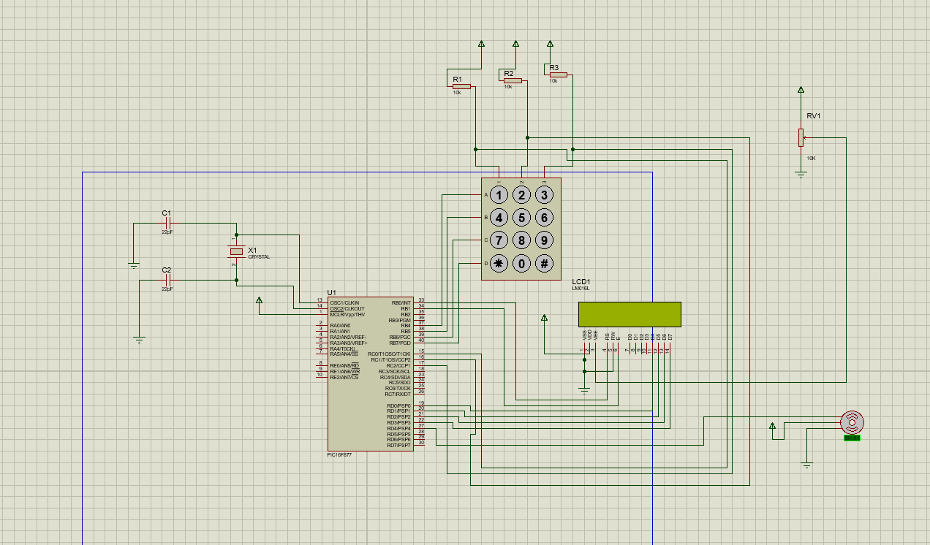

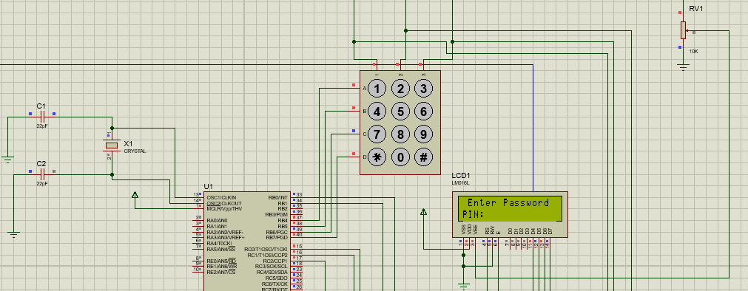

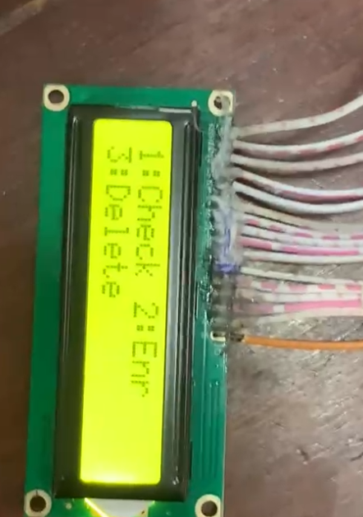
When we start giving supply to circuit it gives us the following menu:
- Press Button 1 to check/verify
- Press Button 2 to enroll
- Press Button 3 to delete

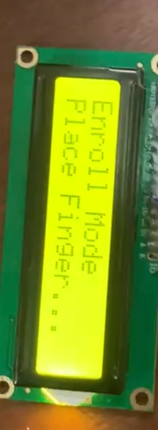
Whenever we start it first we have to enroll a id, after clicking button 2 the following will appear on LCD.

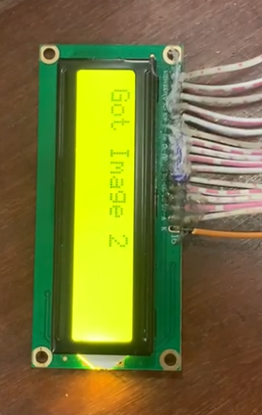
After placing finger the following command will appear on the LCD.

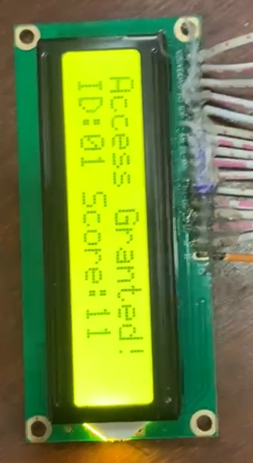

As we click button to check/verify after successful verification servo motor will move from 0 degrees to 90 degrees, and green led light will blink too.

The fingerprint-based door-lock system was tested for functionality, reliability, and response time under various conditions. The AS608 sensor accurately captured and processed fingerprints, with enrolment and verification taking only a few seconds per operation. The PIC16F877A microcontroller efficiently managed communication with the sensor over UART, successfully interpreting all acknowledgment codes and handling errors without system crashes. The system demonstrated consistent performance, providing immediate feedback on the 16×2 LCD and through the status LEDs, clearly indicating access approval or denial.
The SG90 servo motor reliably performed the locking and unlocking functions, rotating to precise angles for secure door operation. The system maintained stable performance over repeated access attempts, with no loss of stored fingerprint data, demonstrating the reliability of EEPROM-based storage. The preliminary Proteus keypad simulation further validated the underlying logic, confirming that input scanning, password verification, and output display were all functioning correctly before integrating the biometric system.
Overall, the system exhibits high accuracy, low latency, and robustness. It handles both correct and incorrect authentication attempts efficiently, recovers gracefully from errors, and provides a user-friendly interface. These characteristics indicate that the design meets the intended performance goals for a small-scale, microcontroller-based biometric security system.

The fingerprint-based door-lock system successfully integrates hardware and software to provide a secure, reliable, and user-friendly access-control solution. Using the PIC16F877A microcontroller and AS608 fingerprint sensor, the system can accurately enrol, store, and verify fingerprints, controlling door access with precise servo actuation. The 16×2 LCD and LEDs provide clear user feedback, enhancing usability and operational clarity.
The preliminary keypad-based prototype in Proteus provided a solid foundation for testing logic and input-output handling before transitioning to the final biometric system. The project demonstrates practical application of embedded programming, UART communication, servo control, and LCD interfacing.
In conclusion, this project highlights how microcontroller-based biometric systems can enhance security and automation. It provides a compact, cost-effective, and scalable solution suitable for academic learning, demonstration purposes, and potential real-world applications. The system is modular, allowing for future improvements such as multi-user enrolment, higher-security thresholds, or integration with IoT-based monitoring.

References:

Circuit digest

Claude ai

Chat gpt

